

**UNIVERSITY OF NAIROBI**

COLLEGE OF BIOLOGICAL & PHYSICAL SCIENCES

SCHOOL OF COMPUTING & INFORMATICS.

**Tour Recommender System**

**(TourAdvisor)**

By

Nyagaka Imaya Dismas

P15/1495/2013

Dr. Stephen Mburu

A project report submitted in partial fulfillment of the requirements of the Bachelor of Science in Computer Science

December 2016

**Abstract**

Most of us have a small computing device that is always with us. As mobile devices decreases in size, weight, and price and increase in power, storage, connectivity, and positioning capabilities, tourists will increasingly using them as electronic personal tour guides and planners (Jeleń, 2008)

However, despite of the advances in mobile technology, we still have to know the places we want to visit and these devices do not store any usable, valuable information about the points of interest to help you plan before and during your trip except phone numbers and addresses. As a result the tourists tend to rely on travel agencies to plan their vacation. With this, there is still need a proper prior plan. This is rigid in a way that a visitor is confined to what the agency had picked during the planning.

Also tourism is experiencing the information overload trend and there is an increasing number of tourism portals and use of social media like Twitter and Facebook. All these provide diverse information on various objects.

The main aim of this idea is to design and develop an application that will run on most phone and will be helpful when visiting some new places and towns in Kenya. These system should be able to suggest the destination before, during and after a visit in case the user is looking for the next destination and support impromptu plans.

The criteria to be used should be simple and natural, for example, a list of all the attraction sites in Kenya, restaurants found close to these places, the constraints of travel by “own” vehicle or by Uber. The system should find a destination that fulfils these criteria, display it on a map and screen, contact information and the photos of them with suggestions of the restaurants found near. It should be helpful for people who are visiting a town in Kenya that the do not have much information about it.

**Declaration**

I hereby declare that this project report is my original work and has not been   
presented for any other University award.

NAME: Nyagaka Imaya Dismas.

REGISTRATION NUMBER: P15/1495/2013

SIGNATURE: _________________________

DATE: _______________________________

This project has been submitted as a partial fulfillment of the requirements of the Degree of Bachelor of Science in Computer Science of the University of Nairobi. The entirety of the project has been realized with full support from my supervisor.

NAME: DR. Stephen Mburu

SIGNATURE: ____________________________

DATE: __________________________________

**Contents**

**Chapter 1 – Introduction** 5

**1.1 Background** 5

**1.2 Problem Statement** 5

**1.3 System Objectives** 6

**1.4 Project Scope** 6

**1.5 Justification** 7

**Chapter 2 – Literature Review** 8

**2.1 Key Concepts** 8

**2.2 Use of ICT in Tourism** 9

**2.3 Existing Similar Systems** 9

**2.3.1 Intelligent Tourist Information System** 9

**2.3.2 TripIt Travel Organizer Free** 10

**2.3.3 TripAdvisor Hotels Flights** 10

**2.3.4 TouristEye – Travel Guide** 10

**2.3.5 WorldMate** 10

**2.4 The ‘Gap’** 10

**2.5 The Proposed Solution** 11

**Chapter 3 – Methodology** 12

**3.1 SYSTEM ANALYSIS** 12

**3.1.1 Agile Development Methodology** 12

**3.1.2 Feasibility Study** 13

**3.1.3 Project Schedule** 15

**3.2 System Design** 17

**References** 24

# **Chapter 1 – Introduction**

## **1.1 Background**

According to the Intelligent System for Tourism (Staab & Werthner, 2002), Tourism is the leading industry worldwide. It represents approximately 11 percent of the worldwide GDP (according to the World Travel & Tourism Council’s tourism satellite account method). In 2015 World Tourism Organization recorded 1.2 billion international tourist arrivals. This was a 4.4% growth from 2014. By region, Europe, the Americas and Asia and the Pacific all recorded around 5% growth in 2015. Arrivals to the Middle East increased by 3% while in Africa, limited data available, points to an estimated 3% decrease, mostly due to weak results in North and East Africa, which account for over one third of arrivals in the region (unwto.org, 2016) .

From the statistics it is clear that significant growth in tourism majorly relies on the availability of relevant information according to the interest and context. The use of technology in providing helpful, relevant, or even interesting updates this sector is inevitable. It is evident that through technology, tourism products and services are able to directly reach the customers. Information about the region and attraction sites enable one to plan his or her visit. As a result of technology, there has been a stable and a steady increase in revenue generation (Deche, 2015).

When travelling to a place or city that you haven’t been there before or don’t know, the very first place that will be visited is probably tourist information. Through the use of existing websites designed for these places or use of the traditional travel information search where querying family and friends or even consulting a travel agent is dominant, we can get maps and obtain information about museums, tourist attraction sites, galleries, and probably entrance costs (Jeleń, 2008).

To make a successful trip one must prepare for it. The truth is that sometimes people do not have enough time for planning and travel arrangement. As a result, majority of them go for trips organized by tourist companies. This limits them visiting some places that they may find interesting during the visit, but if these persons have some proposals for trip, and appropriate system will be very helpful for them in my opinion. With users having some suggestion is a good base to start organizing and optimizing trips and it is easier to change something than to be confined to a travel agency.

## **1.2 Problem Statement**

Tourism has not escaped the information overload trend. We see an increasing number of tourism portals providing diverse information including travel planning, route descriptions, and sites to visit. However, none of the systems supports the user in building a user-defined trip, consisting of one or more locations to visit, accommodations, and plans to visit additional attractions such as a museum and a theater. The question is could we help tourists and give them a tool that is helpful and functional, easy to use and works on numerous mobile devices.

In travel planning, most of the existing systems support only the first stage of the decision process – deciding the destination. However, there are various factors that may affect all the stages of the traveler’s decision-making process. These factors that influence destination choice can be grouped into two groups: personal features (social economic factors e.g age, education, income and psychological and cognitive factors e.g experience, personality, involvement) (Staab & Werthner, 2002)

Despite the existing systems collecting various decision variables, it is expensive to pursue a costly knowledge-engineering activity for each product type – in this case, a catalog of destinations – which requires extensive domain knowledge. This also has a limitation since this catalogs must be built for the particular application.

Also using the available information on the planned or even already visited destination is insufficient to predict the next one. For one to get the next possible destination, additional information must be included – that is the content of the trip.

## **1.3 System Objectives**

**Research Objectives**

1. To investigate on the use of ICTs in tourism sector in Kenya.
2. To identify the decision variables that are in play when a person looks for a vacation destination.
3. To identify appropriate data analytic tools that shall be used in analyzing tweets of a given hash tag.

**System Development Objectives**

1. To analyze data from twitter based on the hashtag.
2. To support the user while determining the next destination using various decision variables.
3. To offer suggestions on the places to visit based on the user criteria.
4. To suggest on the accommodations found close to the attraction site of interest.
5. To offer a flexible travel plan based on the user needs.

## **1.4 Project Scope**

The system shall be used by the tourists visiting new places and towns in Kenya. Any prospective tourist with the application will express his or her information needs about the travel destination and then the system can recommend and suggest on the possible and probable destination.

This system shall be accessible via mobile application and a web interface for administrator. The system shall also perform data analytics using data mining tool and techniques.

## **1.5 Justification**

Although there is information overload trend in tourism, according to (unwto.org, 2016) the number of international tourists arrivals in Africa decreased by 3% in 2015 due to the limited data available. It is evident that the significant growth of tourism by 4.4% in the world is attributed to the availability of relevant information to support decision making throughout various stages.

Despite there being a lot of websites to provide information to the tourists in Kenya, the truth is that none of the systems supports the user in building a user defined trip consisting of one or more locations to visit, accommodations and plans to visit additional attractions. They only support the first stage – deciding the destination.

This project will be looking forward to provide suggestions and recommend on places to visit by filling personalized tour proposals and use of real time information from the tweets on what is trending to give the tourist a probable destination with alternatives. This will facilitate the decision making process.

Unlike the traditional travel information search where querying family and friends or consulting a travel agent is dominant, the system will aggregate information and present it in a manner that is appropriate and natural to support tourism decision making.

The system will also use dynamic maps. GIS will be used to offer information in a location – aware way. Using this technology, the system can deliver suggestions on user’s location, location of objects, available transportation and route description.

# **Chapter 2 – Literature Review**

## **2.1 Key Concepts**

**Data Mining**

Data mining is the practice of examining large databases in order to generate new information. It involves analyzing data from different perspectives and summarizing it into useful information – information that can be used to increase revenue, and cut costs (Palace, 1996). It allows users analyze data from many different dimensions, categorize it, and summarize the relationships identified.

**Global Positioning System**

GPS provides specifically coded satellite signals that can be processed in the GPS receiver, enabling the receiver to compute position accurately, velocity and time. The GPS is being used in mobile phones, cars, boats, planes construction equipment, farm machinery, even laptops and computers (Dana, 1994).

**Google Maps**

Google maps is a service that provides a detailed information about geographical regions and various sites around the world. It is Web-based. In addition to conventional road maps, Google Maps offers aerial and satellite views of many places.

**Android Application**

An Android App is a software application running on the Android platform. Since the Android platform is built for mobile devices, a typical Android app is designed for a smartphone or a tablet PC running on the Android OS.

**Tweets from Twitter**

Recommender system require one to describe a catalog of destinations which requires extensive domain knowledge and this must be built for a particular application.

This approach does not scale unless we pursue a costly knowledge –engineering activity for each product type – in this case destination.

Tweets on destination are stable, reusable concepts such that many recommender systems can exploit the same destination knowledge base.

## **2.2 Use of ICT in Tourism**

There are numerous available applications that are tailored to help the tourists in planning for their vacation. However the destination must be known well for one to plan a visit. None of the systems can suggest of the destination – a place that you don’t know of its interesting object and provide recommendation of the available accommodations on the same platform.

According to the extensive research conducted Interactive Advertising Bureau (IAB) and TNS Infratest (2012) in US shows that the customers who used the Internet to plan and search a single travel and actually purchased totaled 81% in 2012 with a holiday package results totaling 82% (Baggio, Sigala, & Pesonen, 2014).

Some of the advantages that the travelers accrued while using internet travel buying include: the ease and convenience for searching, planning and buying online, time savings associated with the ease of online payment, such as MPESA, credit card payment, instead of other payment methods, such as cash or bank cheque, which may also involve additional time to visit and make payments at an office, competitive prices, special discounts and unlimited add-ons. The also get access to extensive research information that may help them in decision making as they plan for their trip.

The internet is an extensively powerful medium to search, gather and explore information (Baggio, Sigala, & Pesonen, 2014).

## **2.3 Existing Similar Systems**

The idea for intelligent tourist information system is not something new. There are available applications that can give information about the travel destination and can be used in mobile devices (Jeleń, 2008). However, one should exactly know the destination. There does not exist a system that uses the already existing enormous data and analyze it into useful information that can be used to recommend and offer suggestion on where to visit, accommodations and alternatives. Below are different existing systems, and the gap that the app that I want to design and develop will fill.

### **2.3.1 Intelligent Tourist Information System**

As per this thesis, the main idea was to design a system that will run on most phones and palms to help those visiting the new places find route using user criteria. The criteria should be simple and natural, like for example: a list of museums, the famous historical objects, restaurants to visit, constraints to travel by bus and by walking. The system should find a path that fulfils those criteria, show it on screen, show names of objects, some short descriptions and photos of them and possible entrance costs. It should also be able to estimate time needed to travel from one object to the next and if possible, advise which bus line or other public means of transport may be used (Staab & Werthner, 2002).

Despite this thesis being the building block on which my system got inspiration, the system was never developed.

### **2.3.2 TripIt Travel Organizer Free**

This application enables you to plan virtually everything. You don’t have to experience the hassle of booking everything for your tour. It enables you to forward all your hotel, airline, car rental, and restaurant reservations and confirmation emails to tripit.com and the rest will be done for you. With TripIt Travel Organizer app, the place of the visit, the airline and even the car rental should be known prior and before forwarding the information for the trip to be organized for you.

The application has a very easy to use interface and this saves a lot of hustle that is involved while planning for the trip. However, the user is disadvantaged because he or she has to have a good knowledge of the place he or she wants to visit.

### **2.3.3 TripAdvisor Hotels Flights**

TripAdvisor Hotels Flights enables one to book the best flight, find a good place to stay in or amazing travel destination that you might want to go to. With this app, it’s always easy to find the exact location of a certain place. Phone numbers are also provided, which can be helpful if you request for a pickup from the airport to the hotel.

TripAdvisor Hotel Flights application is also an easy to use with interactive user interface. However, it seems to focus on flights and restaurants to stay while on vacation but doesn’t talk nor support the user in deciding the destination.

### **2.3.4 TouristEye – Travel Guide**

This app provides experts’ advice for your travel. It is all-in-one guide that you can take on your trip. It gives information on hundreds of cities all around the world and what’s great is that other users of the app share their experiences daily, giving you an idea on what you can do in your own tour.

TouristEye is another amazing app with amazing features of sharing your experiences during the trip with friends and family. However, just like TripAdvisor, it doesn’t support the user in making decision before and during the trip on the destination choice, transport to use nor suggestions on the alternative place to visit or stay during the vacation.

### **2.3.5 WorldMate**

One can create itineraries and make traveling less of a headache. You can book flights, find the best hotels, and search for car rental services.

With WorldMate, you are saved of the hustles one has to go through while preparing for a trip. However, just like the above applications, it is clear that WorldMate does not support the user in determining destination or next destination.

## **2.4 The ‘Gap’**

Despite there being a lot of websites to provide information to the tourists in Kenya, the truth is that none of the systems supports the user in building a user defined trip consisting of one or more locations to visit, accommodations and plans to visit additional attractions. They only support the first stage – deciding the destination.

|  |  |  |  |  |
| --- | --- | --- | --- | --- |
| Application | Interface | Performance | Covering | User Defined Trips |
| TripIt Travel Organizer Free | Natural | Good | World | No |
| TripAdvisor Hotels Flights | Natural and Clear | Very good | World | No |
| TouristEye – Travel Guide | Natural | Good | World | No |
| WorldMate | Natural | Good | World | No |

TourAdvisor system looks forward to an application that will be helpful when visiting some new places and towns in Kenya. These system should be able offer helpful, relevant, interesting and completely new suggestions on the places to visit with alternatives.

Unlike the traditional travel information search where querying family and friends or consulting a travel agent is dominant, the system will collect information and present it in a manner that is appropriate and natural to support tourism decision – making throughout various stages.

This system will enable tourists to understand and evaluate aspects of the travel. This in turn will facilitate in the planning of their tour without the need of travel agents thus taking the tour experience to a higher new level.

# **Chapter 3 – Methodology**

## **3.1 SYSTEM ANALYSIS**

This is the process of collecting factual data, understand the process involved, identifying problems and recommending feasible suggestions for improving the system functioning.

### **3.1.1 Agile Development Methodology**

The methodology adapted for undertaking the project is the iteratively incremental development methodology. In this agile development methodology the whole requirement is divided into various builds. Multiple development cycles take place here, making the life cycle a “multi-waterfall” cycle.

The development lifecycle is cut into increments or iterations and each iteration touches on each of the traditional phases of development. For example, requirement is an ongoing process that is periodically revisited. As new requirements surface and as the scope changes, the processes continually capture the requirements iteration after iteration. Cycles are divided up into smaller, more easily managed modules. Each module passes through the requirements, design, implementation and testing phases.

A working version of the software is produced during the first module, so you have working software early on during the software lifecycle. Each subsequent release of the module adds function to the previous release. The process continues until the complete system is achieved. This concurrent development approach creates an atmosphere of trial – and – error experimentation and learning. Agile methods promote an iterative mechanism for producing software, and they further increase the iterative nature of the software lifecycle by tightening design – code – test loop as opposed to once per iteration.

Agile ideals can be applied to reduce the cost of change throughout the software lifecycle even if the cost of change is not perfectly flat. To accomplish this flatter cost of change curve, Agile methods promote a number of engineering practices that enables cost effective change. Rather than focusing a lot of effort on big up front design analysis, small increments of functional code are produced according to immediate project need. Straightforward defined processes alone cannot be used to effectively manage complex and dynamic software projects. Risk factors and emerging requirements complicate software development to a point where defined processes fall short. Although it has been attempted in the past, there cannot be a single exhaustive library of defined processes to handle every situation that could possibly surface during a software project development lifecycle.

Agile project management approaches balance the four variables in software development while keeping in mind the limits associated with new product development. In software development there are four broad controls factors. These factors are interconnected, when one changes at least one other factor must also change.

* Cost or Effort – Available resources impacts the amount of effort put into the system.
* Schedule – A software project is impacted as the timeline is changed.
* Requirements – The scope of the work that needs to be done can be increased or decreased to affect the project.
* Quality – Cut corners by reducing quality.

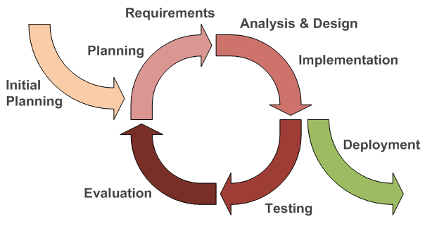

*Figure 1: Iterative Incremental Development.*

### **3.1.2 Feasibility Study**

The feasibility study is the test of the proposed system in the light of its workability, meeting user’s requirements, effective use of the resources and of course, the cost effectiveness. These are categorized as technical, operational, economic and schedule feasibility. The main aim of feasibility study is not to solve the problem but to achieve the scope. The study ascertain the viability for conducting a proposed project and the benefits and probable downsides the project will have to an organization or society.

**Operational Feasibility**

This entails how well the project fits into its target environment and whether it will survive for the foreseeable future in it.

Tour Recommender is operationally feasible since most of the tourists have smart phones and are well versed on how to use and operate it.

**Economic Feasibility**

This is used to determine whether the cost of the prospective project will ultimately be beneficial and profitable to it. It helps in determining the budget to be set aside for the development of the project and what the exactly the monetary amount before the project is ultimately approved.

The Tour Recommender system is economically feasible due to the fact that the hardware and software required to develop the system are already available and thus no need to budget for it. It also uses the tweets as its source of knowledge base in offering new suggestions.

**Technical Feasibility**

If a project possesses the sufficient hardware and software to meet the needs of the project, then it is said to be technically feasible.

Tour Recommender will require an Android smartphone for testing, personal computer for running the IDE used in the development, Java programming language and Android Studio.

**Schedule Feasibility**

The project will be developed in due course within the specified timelines.

**3.1.3 Requirement Elicitation**

Information gathering about this project was done through: Interview, Internet articles, Observations, Journals and Books.

**Publications Review.**

This involved reviewing different publications on the same application domain. The purpose of this research was to gain insight on the approaches that had been used by other persons to solve similar problems. This method was also used to gather information on how to apply certain concepts on solving the problem stated.

**Brainstorming**

Brainstorming was fundamental in creativity and generally coming up with system requirements.

**Research**

Research from journals, similar systems and other sources from the internet stood out when refining the system requirements.

**Interviews**

Informal interviews friends as well as supervisor helped give deeper insight on the tour recommendation process. This information was used to inform the system’s analysis and design phase of the project.

**3.1.4 Functional Requirements**

**1. Recommendation of the places to visit**

The system should be able to recommend the user on the places to visit in Kenya on searching the attraction he or she wants to see. This should also provide alternative places to view the same attraction.

**2. Suggestion on the available accommodations**

On searching an attraction and getting recommendation on places to visit, the system should provide the user with suggestions of the available restaurants that are close to the destination of choice

**3. Support decision on the car rental services**

The system should be able to show you the destination selected and the restaurant in a map so that he or she can make an informative decision on whether to user car rental services or just use the global respected taxi services – Uber.

Additionally a user can make request of the for the Uber taxi via the app with the current user location and destination extracted by the application. This saves the user the hustle of search for a particular destination and setting the current location.

**4. Trending attraction site**

The system should be able to aggregate tweets based on a given hashtag and display this on the screen for a user to make an informative decision and support the decision making process.

**3.1.5 Non Functional Requirements**

**1. Usability**

The system should enable users accomplish their tasks with least effort. Interaction with the user interface should be seamless and easy for users. Further, users should easily learn how to use the system. This implies that the system’s user interfaces should use common diction, icons and menu items.

**2. Security**

Data stored in the system should be secured from data corruption and loss. Each user shall be required to login to the system before accessing it. Each transaction committed on the system shall be associated with the person who initiated the transaction.

**3. Efficiency and speed**

The time taken by the system to respond to a user request should be minimal, possibly negligible. However due to network latency and computation time required to perform some tasks, the system should show allow for computationally intensive task occur in the background while the user interact with the system. Once a task is over, the response can then be relayed to the users.

## **3.2 System Design**

This is the most crucial phase in the development of a system. The logical system design arrived at as a result of systems analysis is covered into physical design. Normally, the design proceeds in two stages:

1. Preliminary or General Design: In preliminary, the features of the new system are specified. The costs of implementing these features and the benefits to be derived are estimated. If the project is still feasible, we move to the detailed design stage.
2. Structured or Detailed Design: In this stage, computer oriented work begin to earnest. The design of the system becomes more structured.

There are several tools and techniques used for describing the system design of the system.

**3.2.1 System Architecture**

This a graphical representation of the system showing the system’s processes. It is more abstract and conceptual than a physical design.

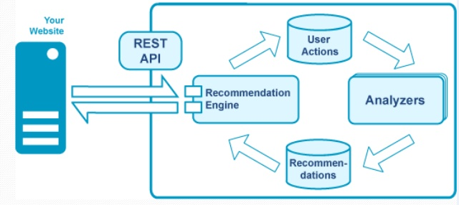

*Figure 4 : General Usage of the system*

**Use Case Design**

This is a list of possible actions or event steps, typically defining the interactions between a role or an actor and the system, to achieve a goal. The actor can be human, an external system or time. With the help of a use case diagram the following are made clear:

* The scenarios in which the system or applications interacts with people, organizations or external systems.
* The goal that it helps those actors achieve.
* The scope of the system.

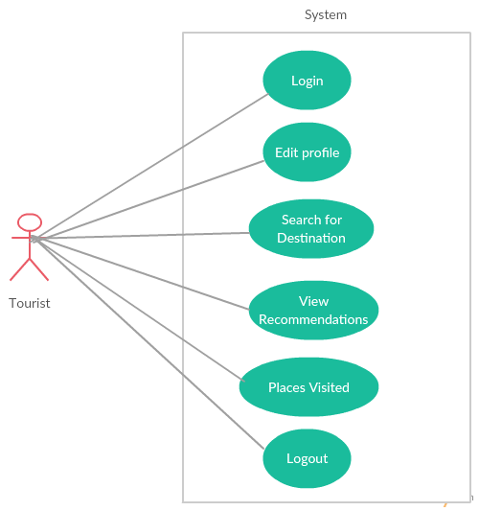

*Figure 5: General Use Case*

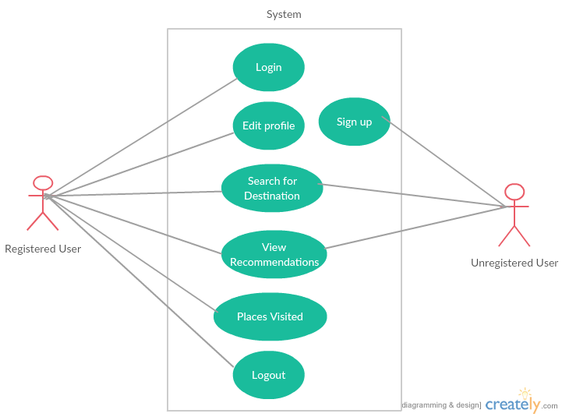

*Figure 6: Use case for different users*

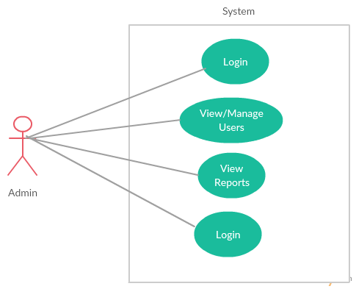

*Figure 7: Admin Use Case*

**3.2.2 Component Diagram**

This depicts how the components are wired together to form larger components or software system. It is used to illustrate the structure of arbitrarily complex systems. It does not describe the functionality of the system but describes the components used to make the functionalities.

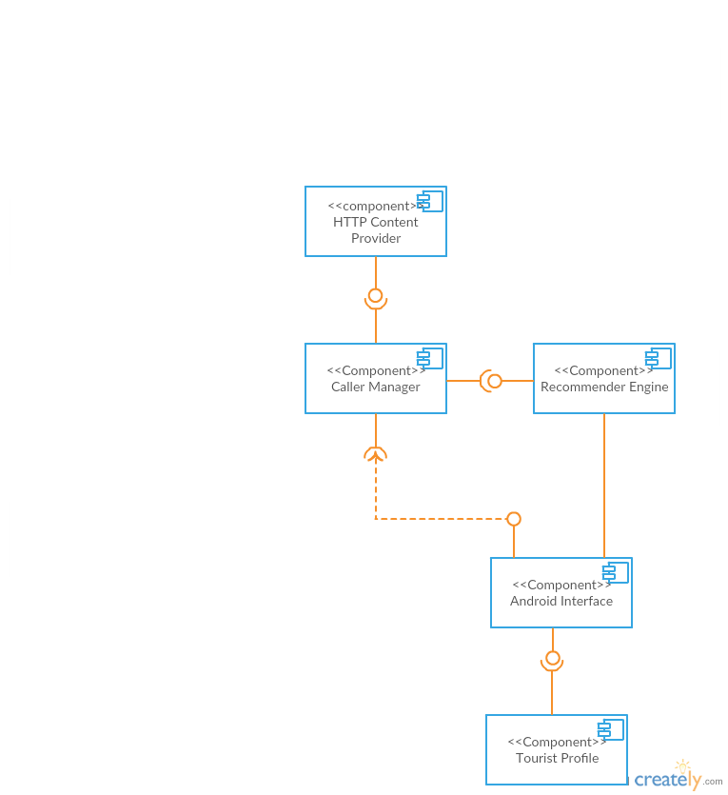

*Figure 8: Component Diagram*

**3.2.3 Database Design**

The system database design has been presented in form of entity relations. In this section, data to be stored is defined. Then the relationship between the data elements is established. Finally, a logical structure upon the data elements is superimposed on these relationships.

**3.2.3.1 Database Entities**

The database shall store the following entities.

**3.2.3.2 Entity Relationships Diagram**

An ERD is used to depict the design of the database. It is a data modeling technique used to create a graphical representation of entities, their attributes and the relationship between them in an information system.

*Figure 9: Context diagram*

**Data Flow Diagram**

DFDs are used to illustrate the process that capture, manipulate, store and distribute data between the system and its environments and among system components. They model how data flows through the system.

# **References**

Baggio, R., Sigala, M., & Pesonen, J. (2014). Information and Communication Technologies in Tourism 2014.

Dana, P. H. (1994). *Global Positioning System Overview*. Retrieved from colorado.edu: http://www.colorado.edu/geography/gcraft/notes/gps/gps_f.html

Deche, K. (2015, April 21). Android Developed Value Addition App To Your Tourism Activities In Kilifi County: MSAFIRI - The Ultimate Travel App.

Jeleń, K. (2008, May 18). Intelligent Tourist Information System. 5-9.

Palace, B. (1996, June). *Data Mining*. Retrieved from anderson.ucla.edu: http://www.anderson.ucla.edu/faculty/jason.frand/teacher/technologies/palace/index.htm

Staab, S., & Werthner, H. (2002). Intelligent Systems for Tourism. 1-14.

unwto.org. (2016, January 18). *World Tourism Organization UNWTO*. Retrieved from unwto.org: http://media.unwto.org/press-release/2016-01-18/international-tourist-arrivals-4-reach-record-12-billion-2015